# Step 1: Launch an EC2 Instance

## Log in to AWS Management Console:

* + Go to the AWS Management Console at https://aws.amazon.com/console/
  + Sign in with your AWS credentials.

## Navigate to EC2 Dashboard:

* + In the AWS Management Console, type "EC2" in the search bar and select EC2 to navigate to the EC2 Dashboard.

## Launch an Instance:

* + Click on the "Launch Instance" button.



* + Choose an Amazon Machine Image (AMI): Select "Ubuntu Server 20.04 LTS (HVM), SSD Volume Type".

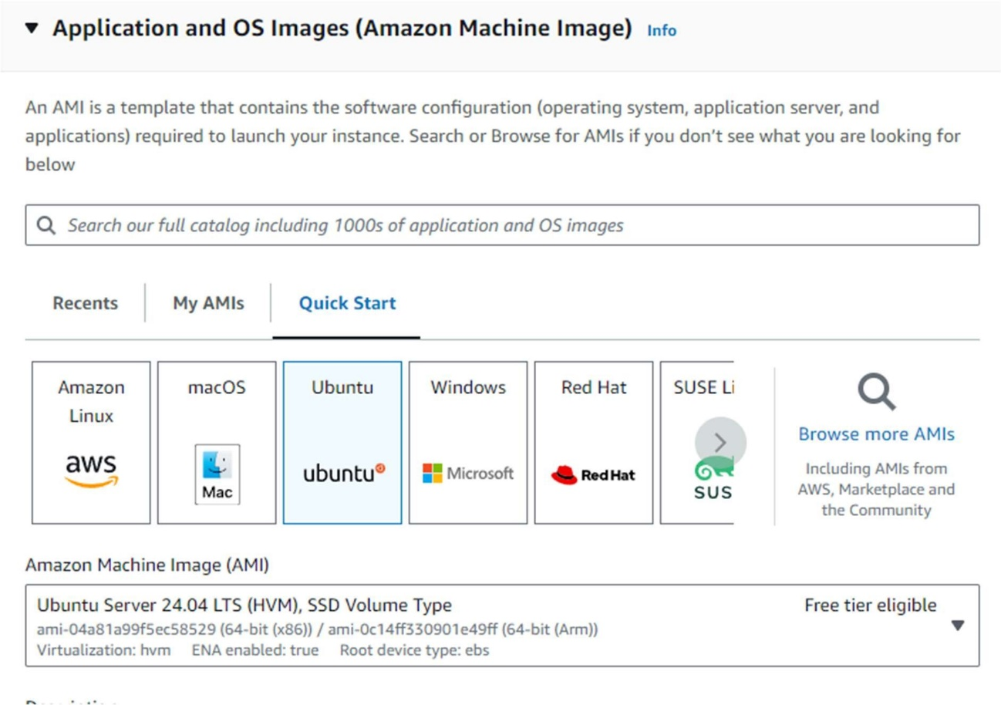

* + Choose an Instance Type: Select t2.micro (eligible for the free tier).

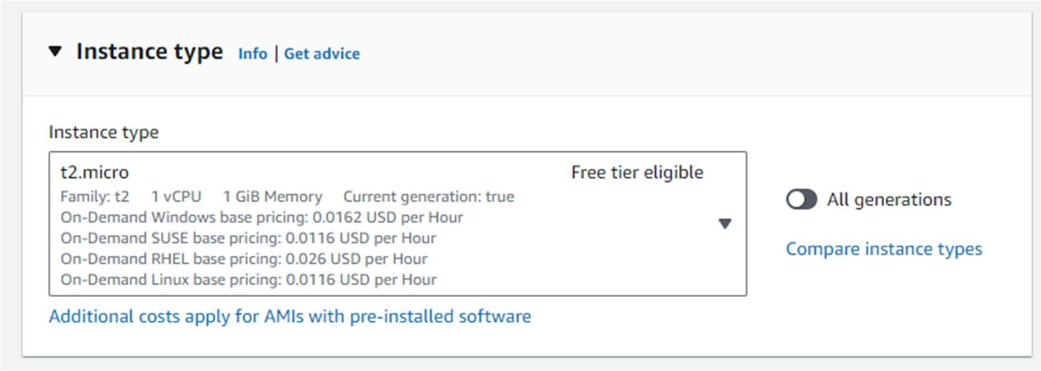

* + Configure Instance:
    - Select an existing key pair or create a new one.
    - Network: Choose the default VPC.
    - Subnet: Choose a subnet in the US-East-1 (N. Virginia) region.
    - Enable Auto-assign Public IP.

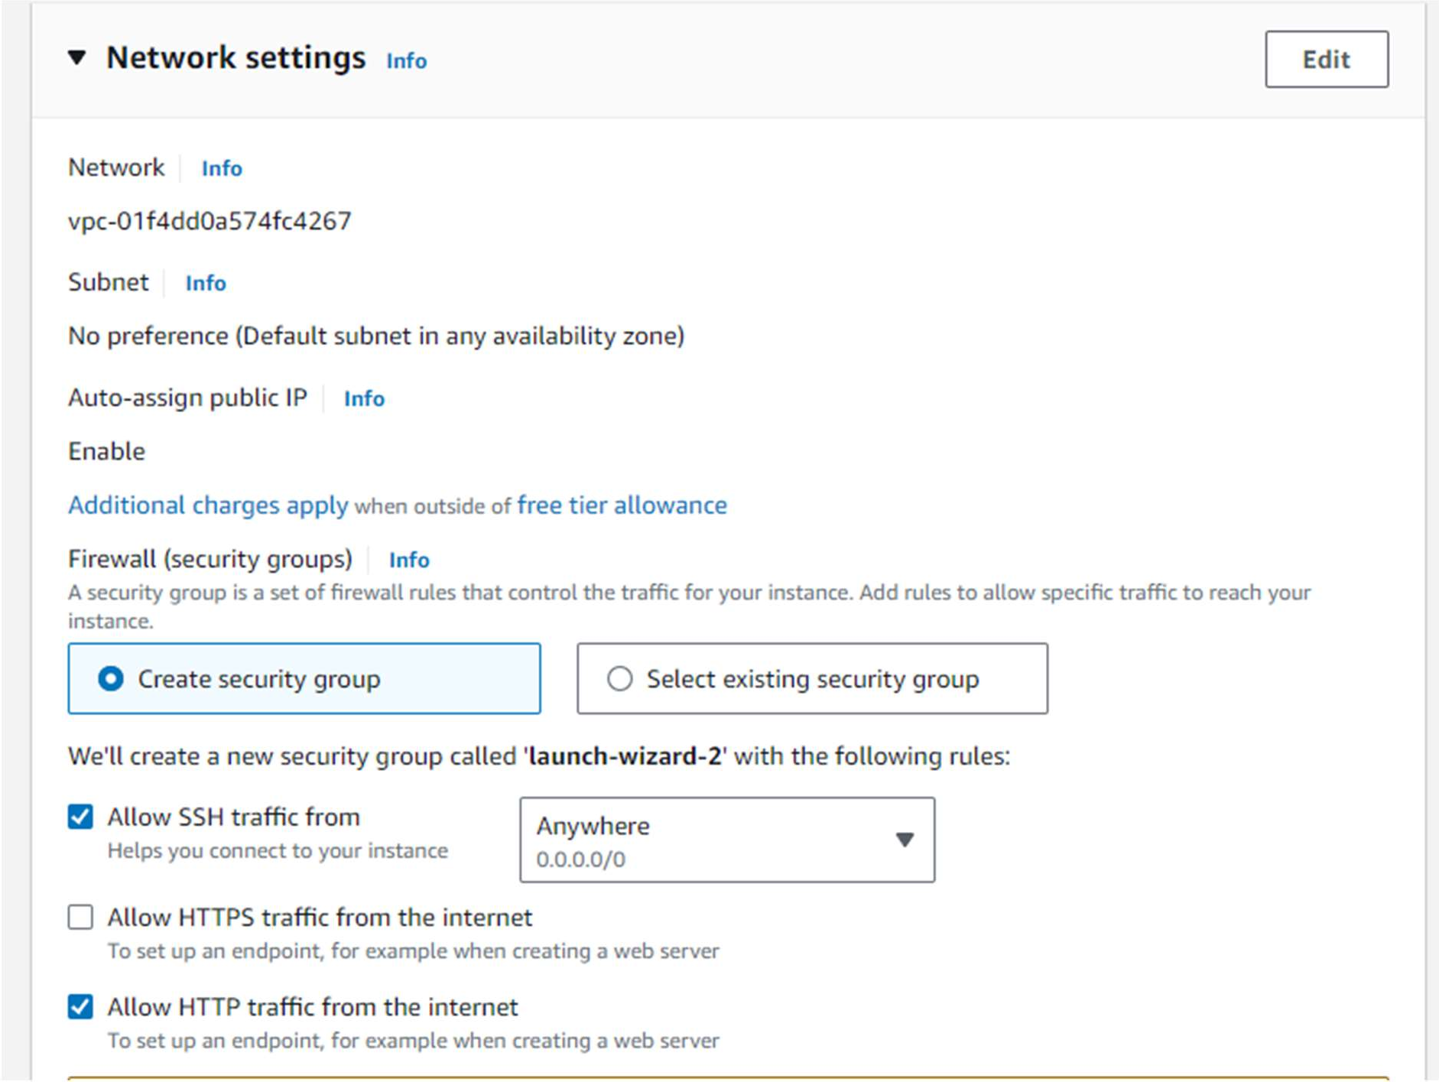

* + Add Storage: Keep the default settings.
  + Add Tags: Add a tag to identify your instance (e.g., Key: Name, Value: Nginx).

## Review and Launch:

* + Review your instance settings and click "Launch".

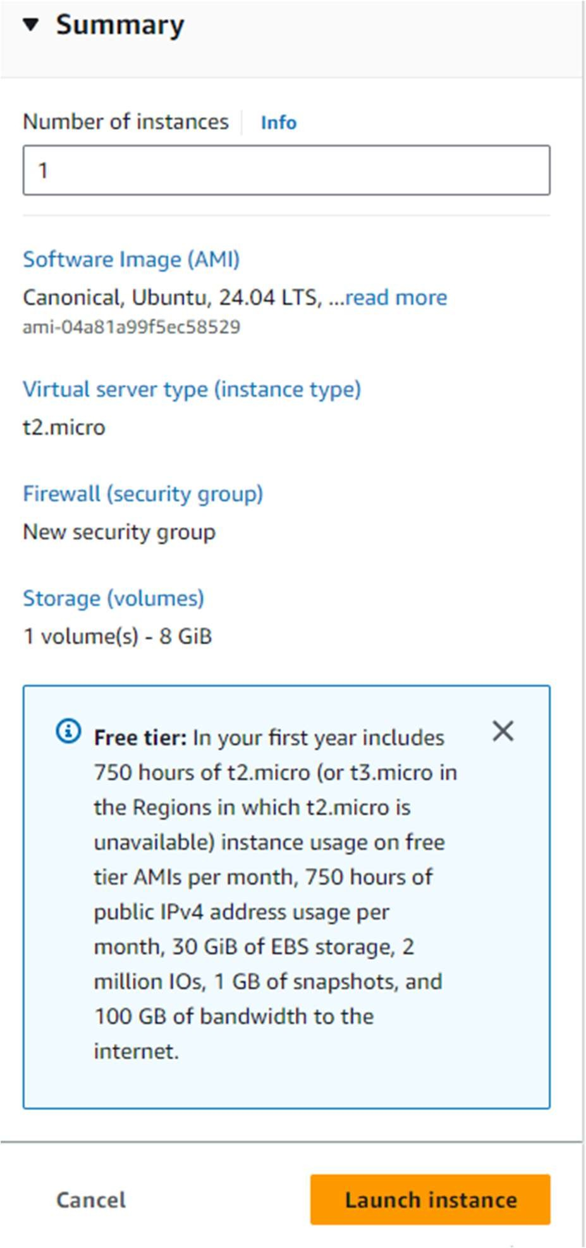

## Configure Security Group:

* + Add a new security group with the following rules:
    - Type: HTTP, Protocol: TCP, Port Range: 80, Source: 0.0.0.0/0
    - Type: SSH, Protocol: TCP, Port Range: 22, Source: 0.0.0.0/0

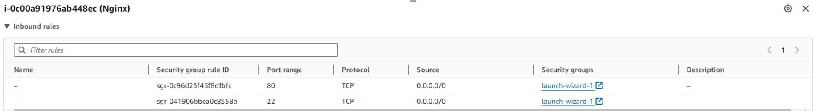

# Step 2: Connect to Your Instance

## Connect to the EC2 Instance:

* + In the EC2 Dashboard, select your instance.
  + Click on "Connect" and follow the instructions to connect to your instance using SSH.

# Step 3: Install Apache and PHP

1. **Update the package index**:

sudo apt update -y

1. **Install Apache**:

sudo apt install apache 2 -y

1. **Start Apache**:

sudo systemctl start apache2

sudo systemctl enable apache2

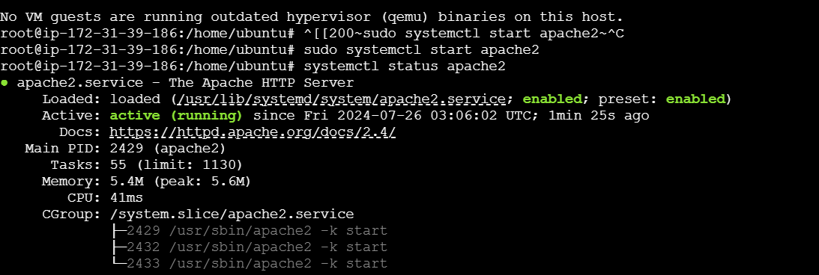

1. **Restart Apache**:

sudo systemctl restart apache2

1. **Create an AMI:**
   * After your instance is up and running in US-East-1, go to the EC2 Dashboard, right-click on the instance, and select "Create Image".
   * Specify details and create the AMI.

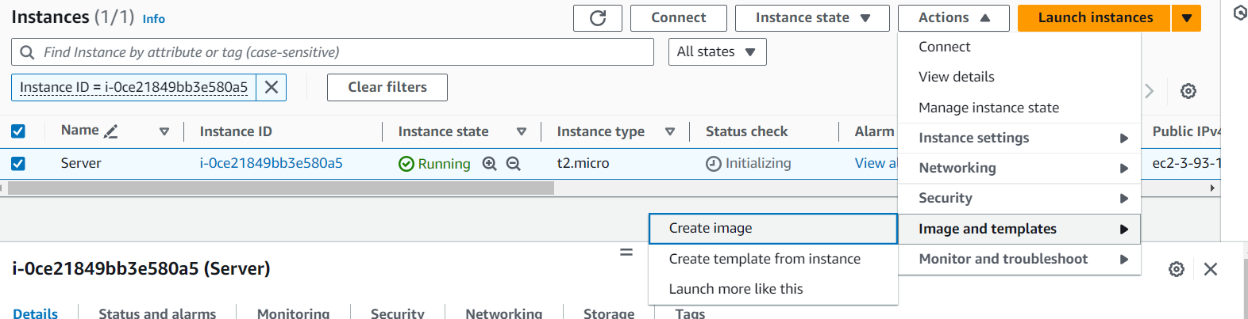

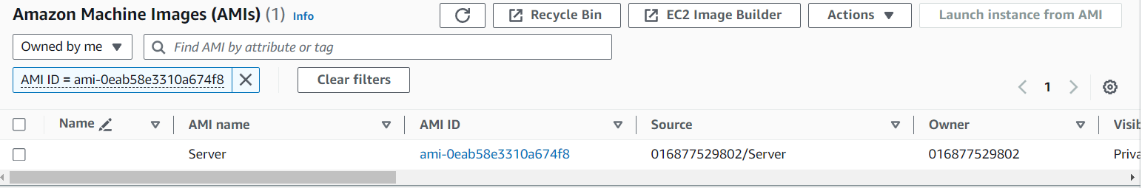

# Step 4: Create a Launch Template

* 1. Navigate to **Launch Templates** in the EC2 dashboard.
  2. Click on **Create launch template**.

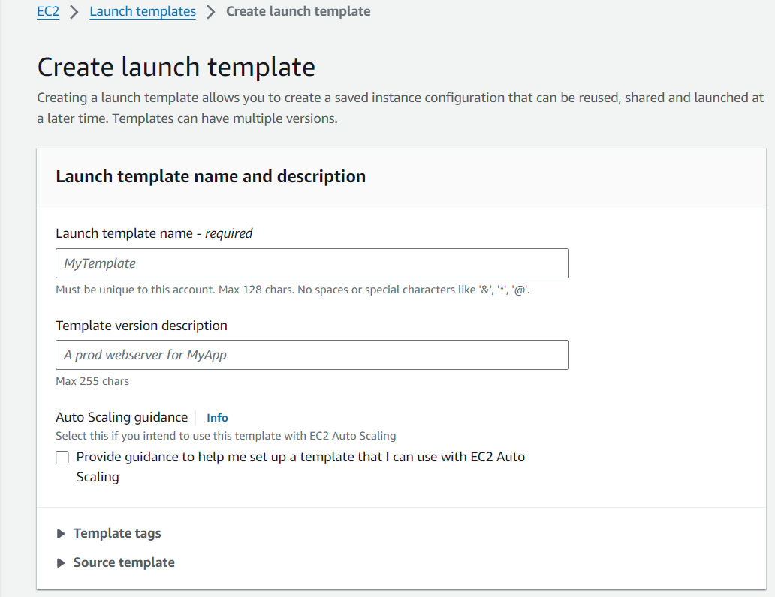

* 1. Fill in template details and instance configuration.
  2. Ensure to use the same AMI, instance type, and security group as your manually launched instance.

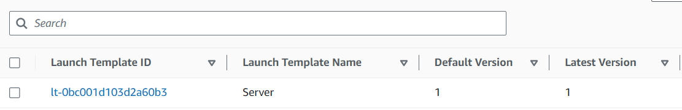

# Step 5: Create an Auto Scaling Group:

* 1. Navigate to **Auto Scaling Groups**.
  2. Click on **Create Auto Scaling group**.
  3. Choose your launch template.
  4. Set the desired capacity to 2, minimum capacity to 1, and maximum capacity to 3.
  5. Configure network and subnets.
  6. Set up scaling policies (optional).

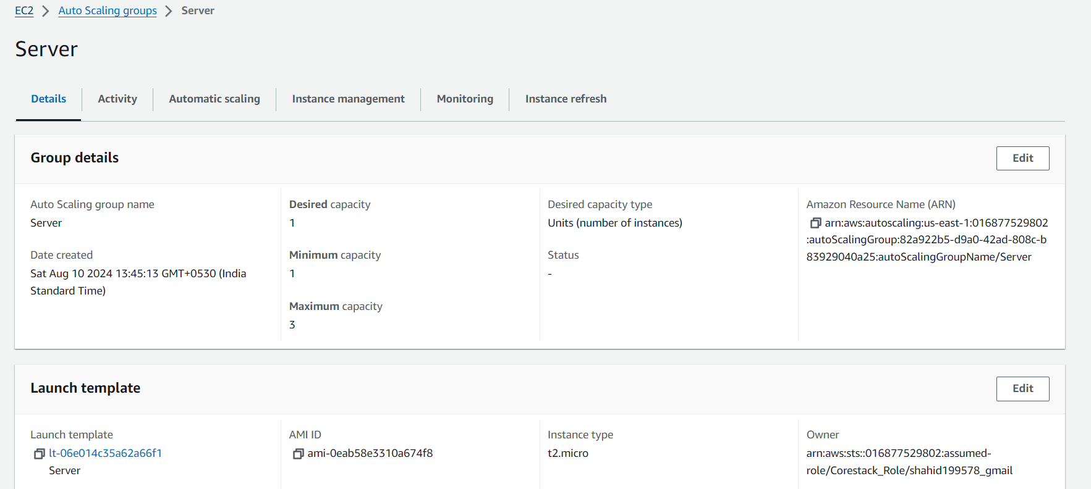

**Steps to Route Traffic Using Route 53:**

1. **Get the Public IP Address of the EC2 Instance**:
   * Go to the **EC2 Dashboard** in the AWS Management Console.
   * Select your EC2 instance and note its **Public IPv4 address**.
2. **Access the Route 53 Console**:
   * Navigate to the **Route 53** service in the AWS Management Console.
3. **Select Your Hosted Zone**:
   * In the Route 53 dashboard, click on **Hosted zones**.
   * Select the hosted zone associated with your domain.

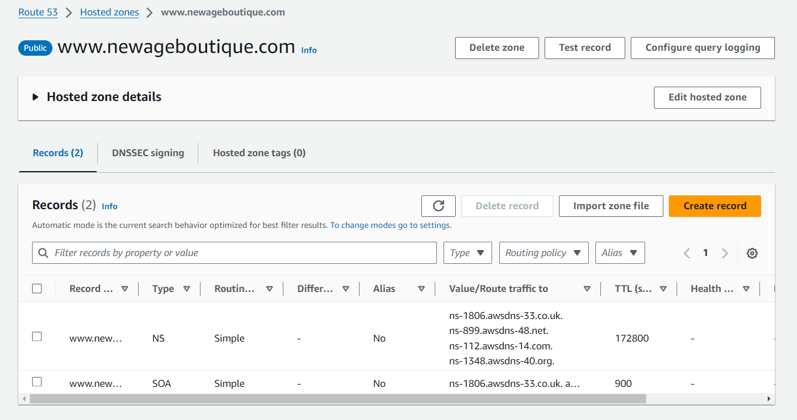

1. **Create an A Record**:
   * Click on the **Create record** button.
   * In the **Record name** field, enter the subdomain or leave it blank for the root domain (e.g., www or @ for the root).
   * For **Record type**, select **A** (IPv4 address).
   * In the **Value** field, enter the public IP address of your EC2 instance.
   * You can leave the **TTL (Time to Live)** value at its default or set a custom value based on your preferences.

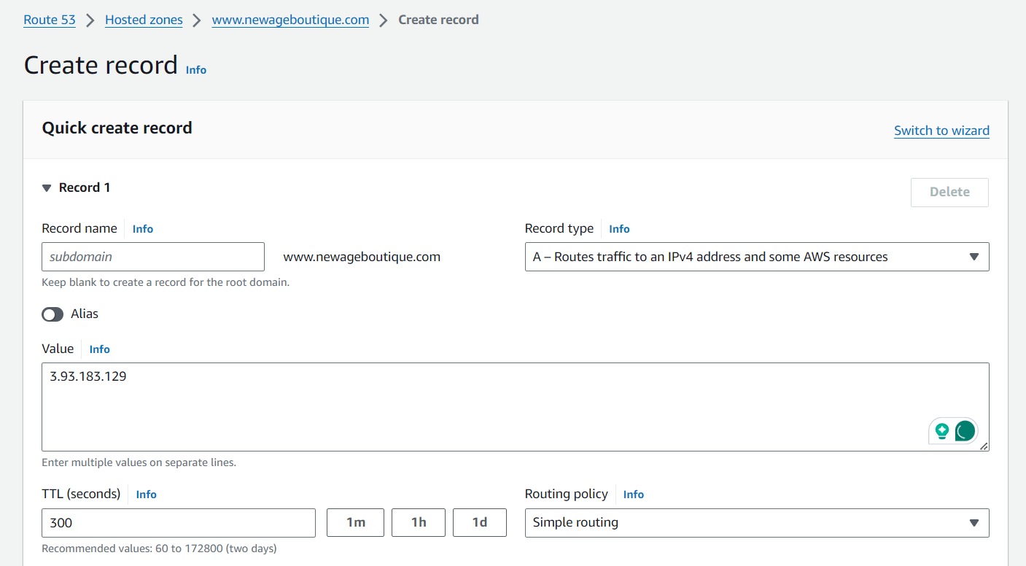

1. **Save the Record**:
   * Click on the **Create records** button to save the new record.
2. **Test the Configuration**:

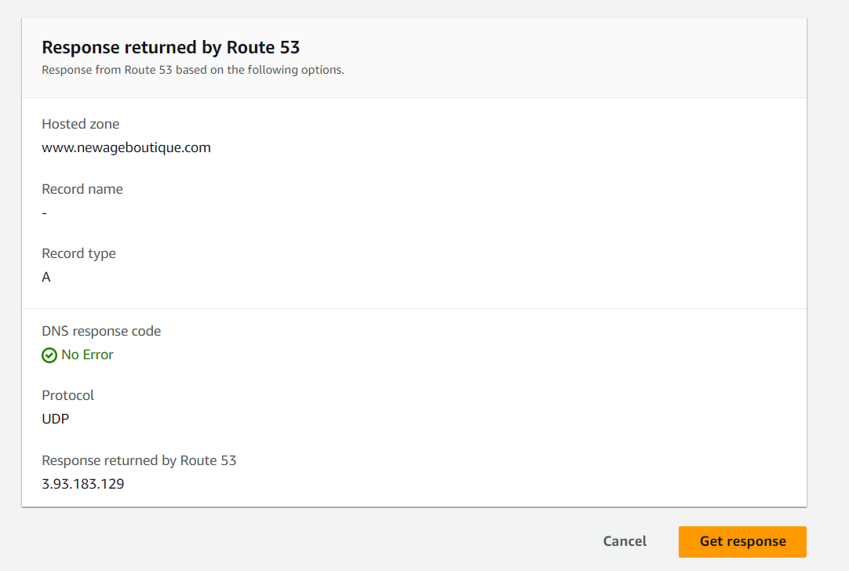

* + Open a web browser and enter your domain or subdomain (e.g., http://yourdomain.com or http://www.yourdomain.com).
  + You should see the Apache web server's default page or the content you've hosted on your EC2 instance.